

OBJECT ORIENTED PROGRAMMING (OOP)

By

Sir Usman Ahmed

LAB REPORT 1 (BSCS III)

Submitted by

NOOR BAHO

CSU-F12-116

DEPARTMENT OF COMPUTER SCIENCE & INFORMATION TECHNOLOGY

THE UNIVERSITY OF LAHORE, ISLAMABAD CAMPUS

**Q1: Write a program that displays “Welcome to UOL” in C++ on screen.**

**Solution:**

#include <iostream>

#include <conio.h>

using namespace std;

int main ()

{

cout<<"Welcome to UOL";

getche();

return 0;

}

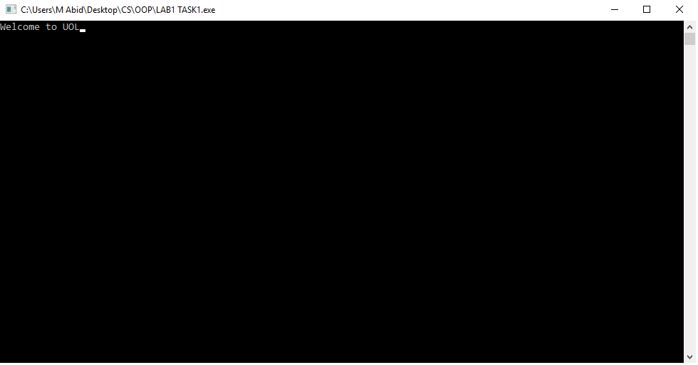

Figure 1.1

**Q2: Write a program that converts temperature from Centigrade to Fahrenheit.**

**Solution:**

#include <iostream>

#include <conio.h>

//temperature converter: Fahrenheit to Celcius and Celcius to Fahrenheit

using namespace std;

float f2c(float f)

{

return (f-32)*5/9;

}

float c2f(float c)

{

return (c*9/5)+32;

}

int main()

{

int mod;

float f, c;

cout<<"To convert Fahrenheit to Celcius enter 1, To convert Celcius to Fahrenheit enter 2: ";

cin>>mod;

switch (mod)

{

case 1:

{

cout<<"Enter temperature in Fahrenheit: ";

cin>>f;

cout<<"Result in Celcius: "<<f2c(f)<<" F";

break;

}

case 2:

{

cout<<"Enter temperature in Celcius: ";

cin>>c;

cout<<"Result in Fahrenheit is: "<<c2f(c)<<" C";

break;

}

}

getch();

return 0;

}

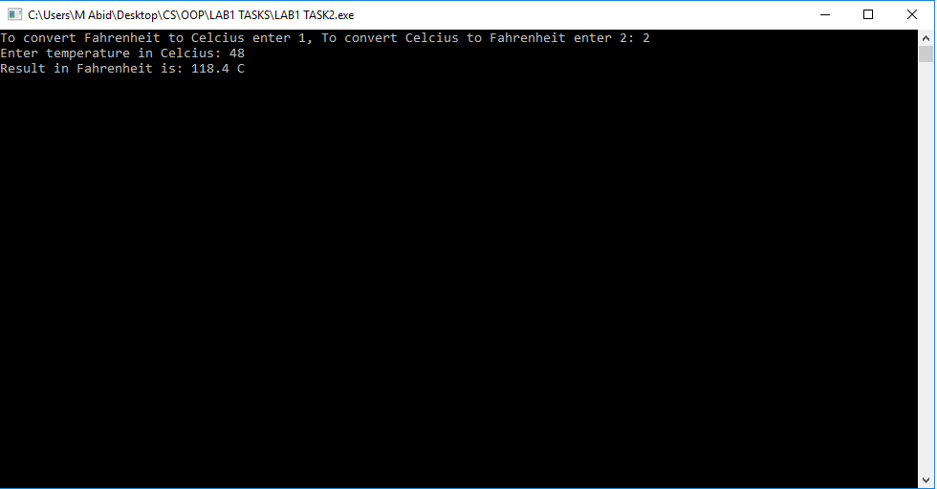

Figure 1.2

**Q3: Write a C++ program to find the volume of box.**

**Solution:**

#include<iostream>

#include<conio.h>

//finds volume of cube

using namespace std;

int main()

{

float v, w, h, l;

cout<<"Enter the length of Box: ";

cin>>l;

cout<<"Enter the width of Box: ";

cin>>w;

cout<<"Enter the height of Box: ";

cin>>h;

cout<<"Volume of box is: "<<l*w*h<<endl;

getch();

return 0;

}

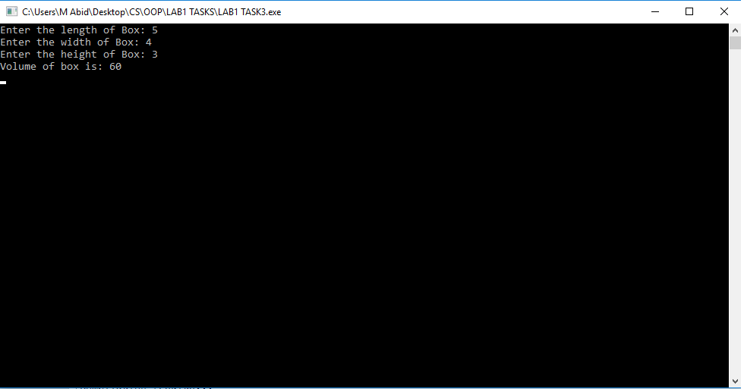

Figure 1.3

**Q4: Write a program that finds the greater number by using conditional operator.**

**Solution:**

#include <iostream>

#include <conio.h>

//finds greater number

using namespace std;

int main()

{

float a,b;

cout<<"Enter 1st number: ";

cin>>a;

cout<<"Enter 2nd number: ";

cin>>b;

if(a>b)

cout<<a<<" is greater than "<<b;

else if(b>a)

cout<<b<<" is greater than "<<a;

else

cout<<"Both "<<b<<" & "<<a<<" are equal ";

getch();

return 0;

}

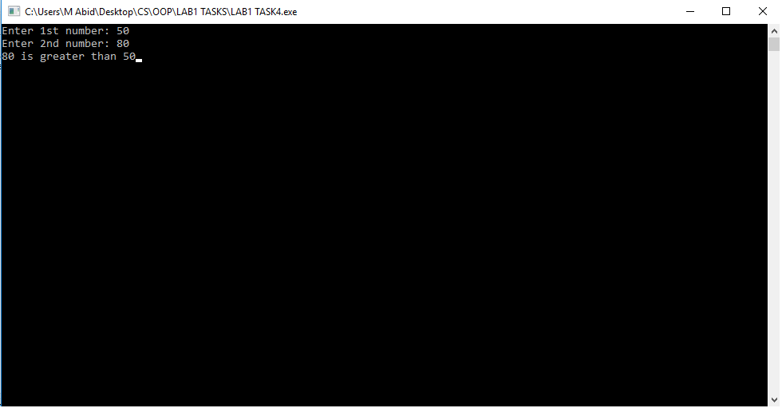

Figure 1.4

**Q5: Write a program that swaps two numbers without involving third variable.**

**Solution:**

#include <iostream>

#include<conio.h>

//swaps values of two variables without involving third variable

using namespace std;

int main(){

float a,b;

cout<<"Enter a: ";

cin>>a;

cout<<"Enter b: ";

cin>>b;

a+=b;

b=a-b; //b got swapped value

a=a-b; //a got swapped value

cout<<endl<<"After Swapping: "<<endl;

cout<<"a= "<<a<<endl;

cout<<"b= "<<b<<endl;

getch();

return 0;

}

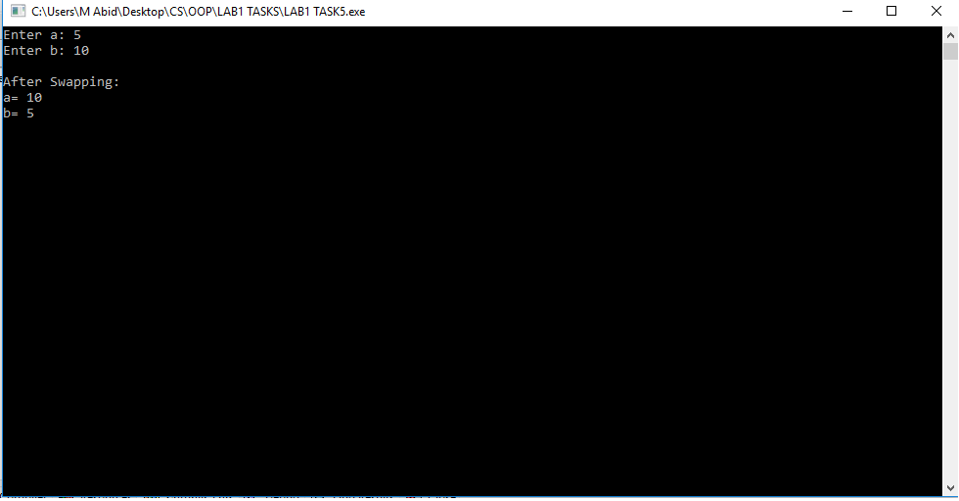

Figure 1.5

**Q6: Write a program that reads character and print their ASCII code.**

**Solution:**

#include <iostream>

#include <conio.h>

//prints ASCI codes

using namespace std;

int asc(char x){

return x;

}

int main(){

char a;

cout<<"Enter character: ";

cin>>a;

cout<<"ASCII code for "<<a<<" is: "<<asc(a);

getch();

return 0;

}

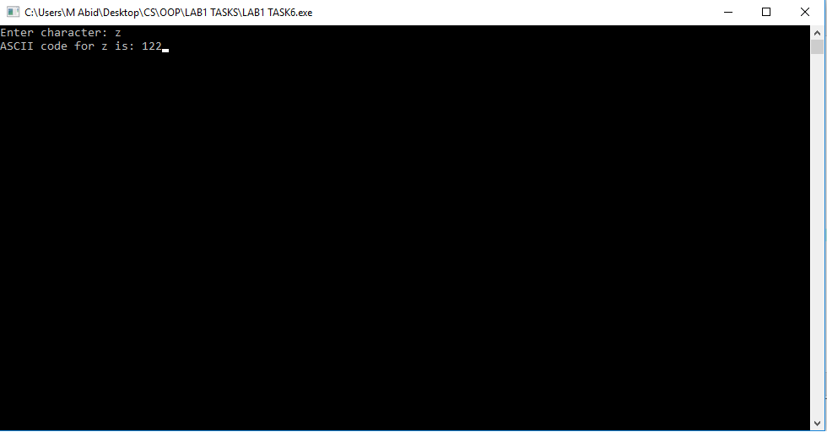

Figure 1.6

**Q7: Write a program to find real roots of a quadratic equation.**

**Solution:**

#include<iostream>

#include<conio.h>

#include<cmath>

//finds real roots of quadratic equation

using namespace std;

int main()

{

float x, y, s; //roots

float a,b,c; //quaderatic equation values

cout<<"Enter values of a, b and c accordingly where quaderatic equation as followed: "<<endl<<"ax^2 + bx +c = 0"<<endl;

cout<<"Enter value of a: ";

cin>>a;

cout<<"Enter value of b: ";

cin>>b;

cout<<"Enter value of c: ";

cin>>c;

s=(b*b)-(4*a*c);

x=(-b+sqrt(s))/(2*a);

y=(-b-sqrt(s))/(2*a);

cout<<endl<<"Real roots are: "<<x<< " & "<<y;

getch();

return 0;

}

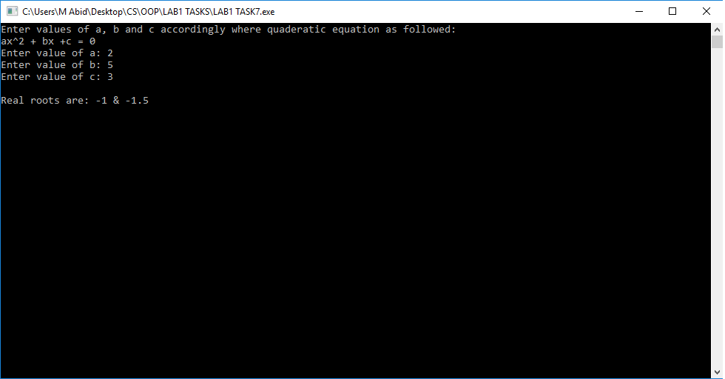

Figure 1.7

**Q8: Write a program that calculates total marks and percentage of a student in 5 different subjects.**

**Solution:**

#include <iostream>

#include<conio.h>

//finds total marks & percentage of subjects

using namespace std;

int main()

{

float st, s1, s2, s3, s4, s5, total, perc;

cout<<"Enter total marks each subject carry: ";

cin>>st;

cout<<"Enter the marks of following subjects"<<endl;

cout<<"Subject 1: ";

cin>>s1;

cout<<"Subject 2: ";

cin>>s2;

cout<<"Subject 2: ";

cin>>s2;

cout<<"Subject 3: ";

cin>>s3;

cout<<"Subject 4: ";

cin>>s4;

cout<<"Subject 5: ";

cin>>s5;

st*=5;

total= s1+s2+s3+s4+s5;

perc= total/st*100;

cout<<endl<<"Total Marks: "<<total<<endl;

cout<<"Percentage: "<<perc;

getch();

return 0;

}

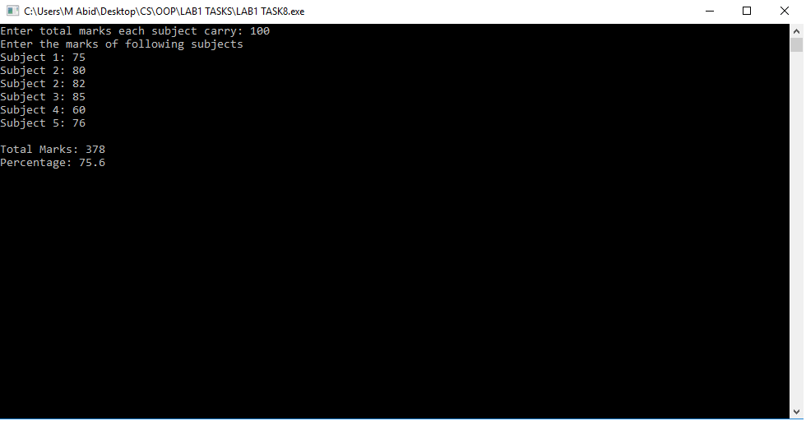

Figure 1.8

**Q9: Write a program that accept five characters in uppercase and print it in lowercase in reverse order.**

**Solution:**

#include <iostream>

#include <conio.h>

//Takes five uppercase characters as input and gives lowercase characters in reverse order as output.

using namespace std;

int main()

{

int asc;

char word[4]={0};

//input();

cout<<"Enter characters one by one: "<<endl;

for(int a=0; a<=4; a++)

{

cout<<"Enter an character: ";

cin>>word[a];

cout<<endl;

}

//lcase();

for(int a=0; a<=4; a++)

{

if(word[a]!=0)

{

asc=word[a];

asc+=32;

word[a]=asc;

}

}

//output

cout<<"Result in lowercase reverse order: "<<endl;

for(int a=4; a>=0; a--)

{

cout<<word[a];

cout<<" ";

}

getch();

return 0;

}

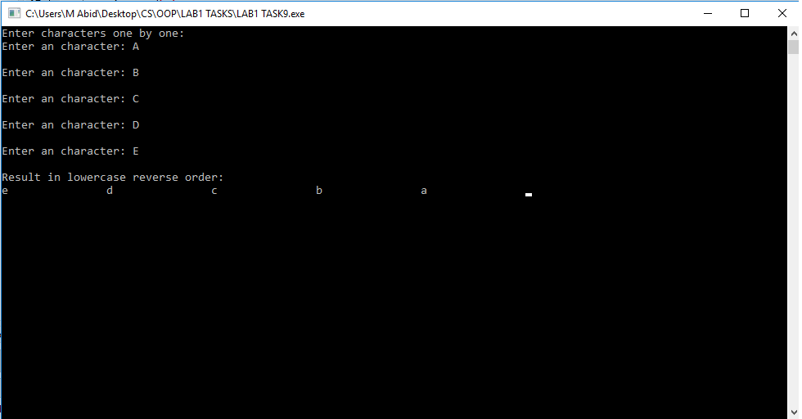

Figure 1.9